Louise Diouf

5/28/2020

Group 9

Sprint 1

From 1 to 3 BY GROUP

From 4 to 6 by LOUISE DIOUF

1. Roommate app

Scheduling for roommate chores

Ex. Every Friday it will remind one roommate to throw out the trash.

Will alert other roommates if a chore is not done or if it is done

**Persona 1** James, age 21 is in college finishing his Junior year. He grew up in North Carolina for most of his life and enjoys working on cars in his spare time. His father is an engineer and his mother is a teacher. He is working towards a degree in finance.

James likes to use software that simplifies tasks and makes everyday life more efficient. Cleanliness is a priority which has been an issue with some of his previous roommates. Even after speaking to these roommates on multiple occasions things are still not cleaned and he doesn’t want to keep asking. Creating an app to send all roommates notifications to clean on respective days would be a solution to this problem.

**Persona 2** Robert, age 18. Robert is a sophomore, who grew up in Idaho and moved to North Carolina for school. In his spare time, he enjoys cooking, reading, hanging out with his friends. Robert is majoring in French.

He likes to cook but never to clean, he always leaves the kitchen a mess and not clean it after he uses it, the house chores are shared but Robert never does his part, his roommates have to ask him over and over to clean and do his part. So now they are creating an App to help them do the house Chores to keep the house clean.

1. A stakeholder of this project would be the landlord who owns the property. The landlord is indirectly benefiting as this app makes sure that roommates are completing their responsibilities on time, which avoids neglect and ensures that the property is properly maintained.
2. Ask an Expert (Who you are and your applicable skills/experiences)

**Seth Close:**

I am a Senior majoring in AI and robotics that is currently working to get experience in robotic design and implementation. I have experience in product and user interface design with mobile device applications, custom prosthetics, as well as devices that test equipment. These experiences have helped me to understand what the user will think and expect from our future product.

**John Iannacone**

I have experience in application design for a social teaching platform and hope to work in systems integration after I graduate in the fall. I have a lot of experience in group collaboration and public speaking/presentation.

**Aditya Bhujle:**

Application Programming

Applicable Skills: Built a few websites and apps in JavaScript and Python. Have experience in state management from frameworks like React and Angular.

**Shail Shah:**

I am a junior in Computer Science with concentration in Cyber Security. I will graduate in summer of 2021. I have experience in programming robots in Python. I have experience with networking and security. I also have experience with customer service and handling customer complaints.

**Louise Diouf**

I’m a senior graduating in December 2020 with a double major in Computer Information Technology and french and english/French translation certificate. I work in customer service in our family business and also work as an interpreter at Presbyterian Hospital.

Have some experience in designing an application, interface, prototyping.

1. Here is an image if the Map I drew and took a picture to add it to the document.

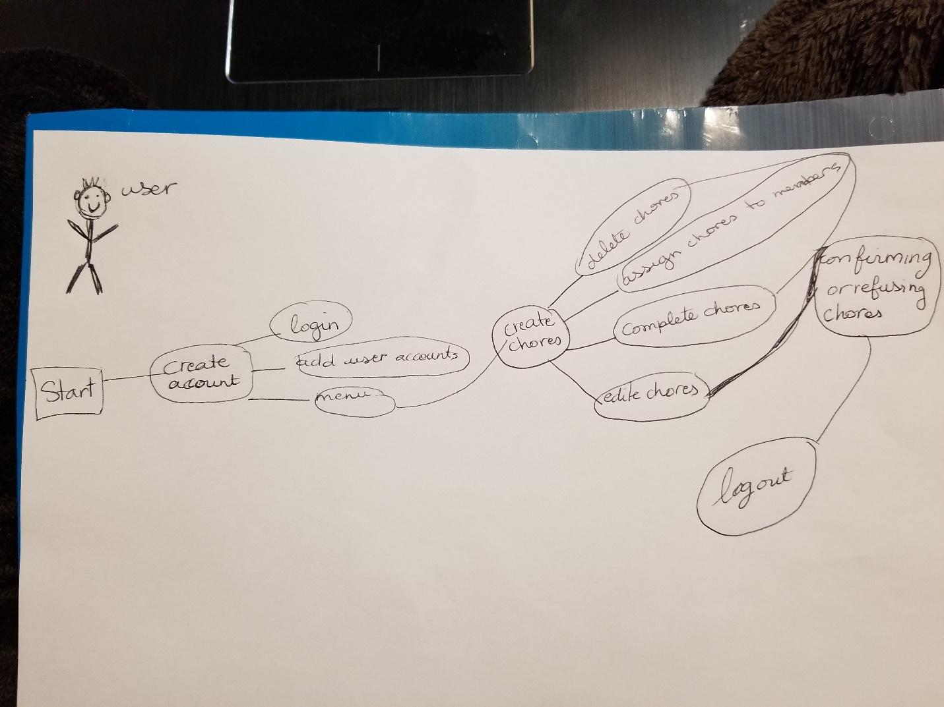

1. This app is very user friendly so many people can use it. Here is a little **scenario** of how the App will be used.

From the start the user can create an account by responding to all required information. Once account is created the user can log in and add account users to add the roommates on the App. From there user can access to the menu where users will find the option to create the different chores they share in the house. It can be cleaning the living room, washing dishes, vacuuming, dusting etc. from the different chores created the users can delete chores, assign chores to each other, edit chores, check the chores the users already completed and the confirming or refusing the chores assigned to you. User log out to finish.

If I take the example of a user name TOM, he shows us what he goes by when he is using the Roommate App:

**User = TOM**

Tom log in on his account and choose to do his part of the chores. Tom goes to the menu to choose the chores he has been assign and do them all. As he is doing it, Tom is putting checks on the chores he has done until he completed all his chores. Tom can do more if he chooses to on the chore’s menu. And then once he is completely done, he will log out on his account.

**User stories**

As a user I want to be able to create an account.

As a user I want to be able to log in in my account.

As a user I want to be able to add users to the account

As a user I want to be able to create different chores

As a user I want to be able to edit the chores menu

As a user I want to be able to check the chores I completed

As a user I want to be able to accept or refuse chores

As a user I want to be able to see the different chores other users completed.

1. **Features lists**

Overview

Calendar

To do list

Chores

User journal

Settings